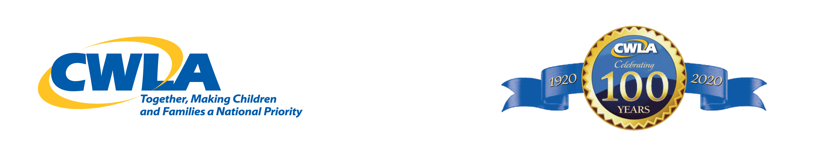
These 2 columns combined is what states just received from FY 19 appropriations

State FY 18 Award (partial) FY 19 Make-Up FY 18 Shortfall FY 19 Award Partial
Alabama $9,315 $14,685 $875,707
Alaska $146,327 $230,673 $149,594
Arizona $2,554,714 $4,027,286 $3,152,544
Arkansas $478,378 $728,505 $601,538
California $3,107,420 $4,898,580 $4,063,806
Colorado $503,995 $794,505 $420,866
Connecticut $4,658 $7,342 $62,155
Delaware $41,531 $65,469 $72,163
District of Columbia $0 $0 $205,429
Florida ` $116,441 $183,559 $1,427,468
Georgia $614,808 $969,192 $614,707
Hawaii $108,096 $170,404 $108,509
Idaho $201,055 $316,945 $15,802
Illinois $1,396,709 $2,201,791 $2,138,304
Indiana $1,579,521 $2,489,979 $1,228,360
Iowa $679,821 $1,071,679 $724,795
Kansas $1,553 $2,447 $900,727
Kentucky $295,760 $466,240 $36,872
Louisiana $492,157 $775,843 $878,604
Maine $333,409 $525,591 $277,836
Maryland $240,451 $379,049 $44,773
Massachusetts $448,492 $707,008 $919,953
Michigan $644,306 $1,015,694 $426,660
Minnesota $389,689 $614,311 $2,086,157
Mississippi $329,140 $518,860 $623,925
Missouri $576,771 $909,229 $1,175,949
Montana $50,458 $79,542 $323,946
Nebraska $359,026 $565,974 $320,785
Nevada $311,868 $491,632 $179,092
New Hampshire $21,153 $22,347 $281,543
New Jersey $302,358 $476,642 $368,719
New Mexico $24,841 $39,159 $209,116
New York $169,422 $267,078 $493,029
North Carolina $529,224 $834,276 $409,278
North Dakota $204,354 $322,146 $330,267
Ohio $358,444 $565,056 $48,460
Oklahoma $2,274,091 $3,584,909 $880,184
Oregon $518,162 $816,838 $467,482
Pennsylvania $721,546 $1,137,454 $2,714,822
Rhode Island $83,449 $131,551 $46,353
South Carolina $69,865 $110,135 $93,496
South Dakota $210,564 $331,936 $105,348
Tennessee $181,454 $286,046 $69,530
Texas $1,759,228 $2,773,272 $1,425,361
Utah $50,070 $78,930 $719,001
Vermont $255,006 $401,94 $145,117
Virginia $556,005 $876,495 $857,534
Washington $0 $0 $5,267
West Virginia $217,356 $342,644 $950,767
Wisconsin $482,260 $760,240 $442,199
Wyoming $106,543 $167,957 $36,345
Puerto Rico $0 $0 $0
Total $25,111,262 $39,585,738 $35, 156,246

These are the totals received in incentives payments for the Adoption and Legal Guardianship Incentive Payment Program for federal Fiscal Year 2019. The second column represents the funds states received to make-up for a shortfall in federal payments from last year (2018). The third column is a partial payment states received for this year’s payment. Add together column 1 & 2 to determine what the state earned in FY 2018. Add column 2 & 3 to determine what the state received this October 2019 for FY 2019.
This year’s shortfall should be made up next year at this time. Gradually Congress is making up the shortfall by appropriating $75 million a year. Recently states have been earning approximately $64 million a year.

