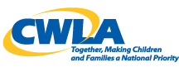

October 6, 2015

The Honorable Ron Wyden
221 Dirksen Senate Office Building
United States Senate
Washington DC 20510

Dear Senator Wyden:
In the coming weeks you may have an opportunity to consider legislation to make improvements in our nation’s child welfare system. It is important that such legislation include investments in reforms that will build the needed continuum of care for children in foster care and families that are affected by state welfare systems. That continuum must include prevention of child abuse and neglect to the prevention of unnecessary placements into foster care to strong services for the children and adults who make up foster and adoptive families.
In any pending and future deliberation we hope you will remember our support for an important piece of legislation S. 429 the Family-based Foster Care Services Act.
CWLA believes that we need a system that can keep children out of foster care whenever possible but provide the best care whenever necessary. With the 2013 and 2014 increases in foster care placements this is even more urgent.
Therapeutic foster care is one critical element on the needed continuum of care in an effective child welfare system. Inclusion of S. 429 in future legislative reforms would be an important step for Congress to take.
Attached for your benefit is a recent statement that CWLA along with the Foster Family-Based Treatment Association sent earlier in this Congress we think it includes important information.
Again thank you for your support and interest in this issue we hope we can come together around some important federal investments and reforms in child welfare.

Sincerely,
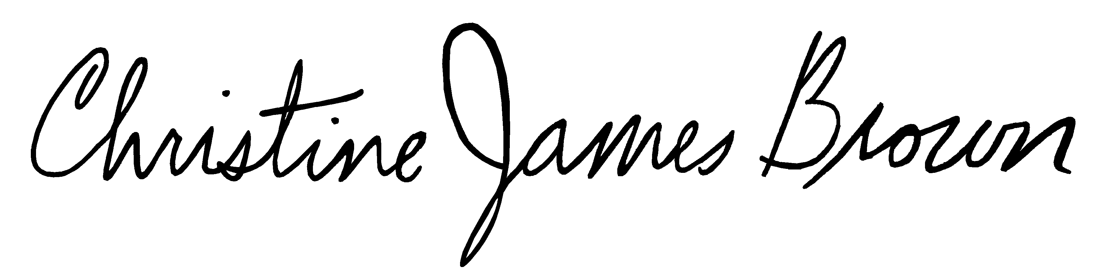
Chris James-Brown
President and CEO

