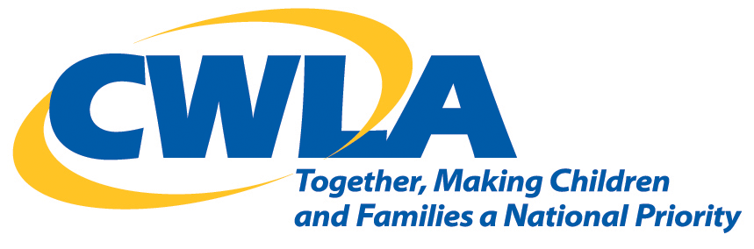
Contact: Chris James-Brown Child Welfare League of America
OFFICE: 202-688-4191 727 15th Street, NW 12th Floor
EMAIL: CJamesBrown@cwla.org Washington, DC 20005

CWLA Statement
New Regulations To Improve The Indian Child Welfare Act (ICWA) Proceedings
Washington, DC. This week, the Bureau of Indian Affairs (BIA) issued new regulations to update and improve the enforcement of the Indian Child Welfare Act (ICWA). We believe that ICWA and its effective implementation are consistent with CWLA’s National Blueprint for Excellence in Child Welfare, that serves as the foundation and framework for achieving the vision that all children will grow up safely, in loving families, with everything they need to flourish–and with connections to their culture, ethnicity, race and language.
CWLA believes that these regulations which are the culmination of over 2100 comments from individuals, organizations, states, and tribes, and which guided the development to ensure there will be more uniformity and certainty in how ICWA protections are provided for all parties involved are long overdue. We believe they will provide greater clarity when it comes to helping states, courts and tribes ensure that all American Indian and Alaska Native children and families who are in state child welfare systems receive the protections they need.
In 1978 Congress created ICWA in an effort to recognize the rights, needs and well-being of tribal children and tribal families. Despite this, we know that children from tribal communities enter the child welfare system at disproportionate rates. That Act, (ICWA, P.L. 95-608) was an effort to preserve cultural and family ties among Native American children and families and to ensure respect for tribal authority in decisions concerning the placement of Indian children in out-of-home care. But further clarification and implementation was required.
CWLA believes that the regulations help states understand more clearly when ICWA applies, how to verify if a child is an” Indian Child” under the law, promotes uniformity in State ICWA proceedings, as well as identify what actions are necessary to protect the best interests of Indian children and provide efforts to prevent the breakup of the family.
The regulations put forward a standard of practice for Indian children and families that is consistent with other federal law and nationally-recognized practice standards (including CWLA’s) for all children. As part of a coalition of 18 nationally-recognized child advocacy organizations, we recognize ICWA as the “gold standard” in child welfare practice.
With these regulations, CWLA will redouble its work to ensure that service providers fully implement ICWA and the CWLA standards of excellence in child welfare.
Since 1920, the Child Welfare League of America (CWLA) has been the nation’s pre-eminent organization dedicated to ensuring that abused and neglected children are protected from harm and have the tools and resources they need to grow into the healthy and happy adults we want them to become. CWLA is the trusted authority for professionals who work with children and the only national organization with members from both public and private agencies, providing unique access and influence to all sectors of the children’s services field.

